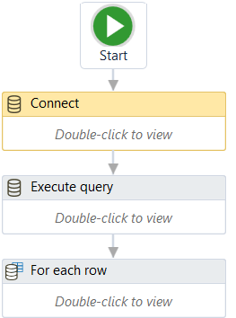

When using an Execute query activity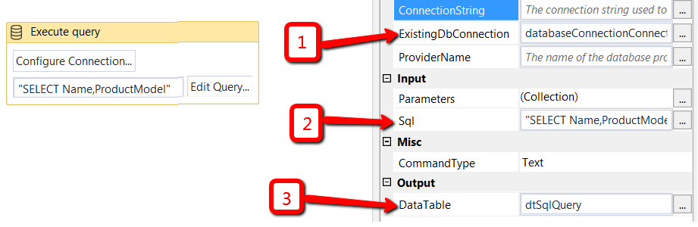

1. ExistingDbConnection: use the output from Connect activity.

2. SQL: Write the Sql query between inverted commas as a string.

3. Right click on DataTable field , Create Variable and give a name to your datatable.